Domestic Animal Business
Application for Registration
CASEY.VIC.GOV.AU

Applicants must sign and complete or amend the details below and return this application with the fee payable to the Council office at the below address
Applicant first name |  |  | Surname
Company name
Postal address
(Registered address of company)
Suburb |  |  | Postcode
Residential address
Suburb |  |  | Postcode
Premises address
Suburb |  |  | Postcode
Proprietor first name |  |  | Surname
Business trading name |  |  | ABN
Premises description
Premises owner/occupier | ☐ Owner | ☐ Occupier | Animal types  (Dogs, cats, both)
Business phone |  |  | After hours
Email address
Application Must Include:
New Applications: $680.00 application fee (50% refundable if Registration not granted)
Renewals: $340.00 non-refundable application fee
I/We the undersigned hereby apply to renew/register/transfer for the year ending 10 April 2019 in accordance with Section 47 of the Domestic Animals Act 1994.
The applicant undertakes to comply with any conditions imposed by Council.
Signature of Applicant/s
(in case of a Company the signing officer must state his/her
position of authority in such Company)

Privacy Statement
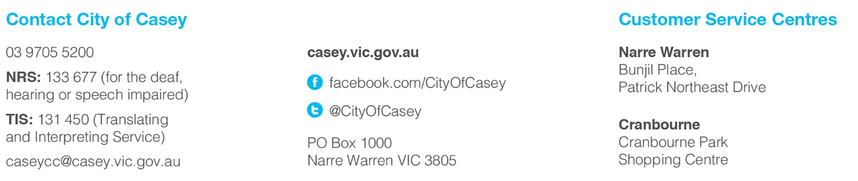
City of Casey is committed to protecting your privacy. Your personal information will be handled in accordance with the Privacy and Data Protection Act 2014. All personal information collected by the City of Casey will only be used for the purposes outlined within our Privacy Policy. Council’s Privacy Policy is available from our website www.casey.vic.gov.au/council/your-council/privacy and all Council Customer Service Centres. For further information about how Council manages and uses your personal information or how you can access and/or amend your personal information please contact Council’s Privacy Officers via our website www.casey.vic.gov.au/council/contact/feedback-form or by calling on 9705 5200.

