Change my child’s kindergarten registration details
Complete this form if you:
Change to Kindergarten
Registration
- Have moved house or need to update your contact details.
- Want to change your child's preferred kindergartens. Change of preferred kindergartens received after 30 April in the year before attendance will be considered as late registration.
- Want to transfer your child's year of attendance at kindergarten. This is only available for children born between 1 January and 30 April.
- Want to cancel your child's registration/enrolment.
- This form can be completed online at City of Casey Website – Google “update kinder registration Casey”

Please return this form via one of the following methods:
By post:
Kindergarten Enrolment and Planning Officers
City of Casey
PO Box 1000
NARRE WARREN VIC 3805
Email:
kinderenrolment@casey.vic.gov.au
In person:
At a City of Casey Customer Service Centre

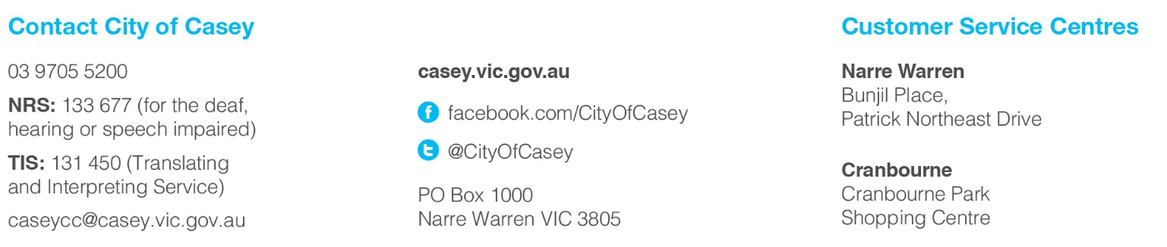
Kindergarten locations
The City of Casey takes registration for all services listed on this page.
Suburb Kindergarten Name Address
Berwick Berwick Kindergarten 30-32 Peel Street
Brentwood Park Kindergarten 26 Bemersyde Drive
Bridgewater Kindergarten 45 Bridgewater Boulevard
Gwendoline Kindergarten 25 Gwendoline Drive
Mansfield Street Kindergarten 11 Mansfield Street
Rossmoyne Kindergarten 19 Beldale Court
Timbarra Kindergarten 20-26 Parkhill Drive
Clyde North Selandra Kindergarten 45 Haflinger Avenue
Clyde North Kindergarten 2A Moroak Drive
Cranbourne Bowen Street Kindergarten 20-22 Bowen Street
Carlisle Park Kindergarten 2-20 Majestic Boulevard
Clarendon Street Kindergarten 29-43 Clarendon Street
Rangebank Kindergarten 40-46 Lesdon Avenue
Cranbourne North Arbourlea Kindergarten 75 Wheelers Park Drive
Merinda Park Kindergarten 149-153 Endeavour Drive
* Woodbine Road Kindergarten 4 Woodbine Road
Cranbourne West Fairhaven Kindergarten 42-52 Fairhaven Boulevard
Mayone bulluk Kindergarten 66 Bradman Drive
Willora Kindergarten 75-81 Willora Crescent
Cranbourne East Hunt Club Kindergarten 40 Broad Oak Drive
Livingston Kindergarten 31S Parkhurst Drive
Doveton Autumn Place Kindergarten 29 Autumn Place
Devon Meadows Botanic Ridge Interim Kindergarten 50 Worthing Road
Endeavour Hills Allara Kindergarten 15-17 Gleneagles Drive
Chalcot Lodge Kindergarten 26 Haverstock Hill Close
David Collins Kindergarten 23-25 David Collins Drive
Hartley Ridge Kindergarten 30-36 Singleton Drive
James Cook Kindergarten 55-63 James Cook Drive
Reema Kindergarten 42 Reema Boulevard
Hallam Hallam Gardens Kindergarten 26-28 Nettle Drive
Hallam Kindergarten 30 Harmer Road
Hampton Park Coral Drive Kindergarten 187-191 Coral Drive
Hampton Park East Kindergarten 16-20 Stuart Avenue
Regans Road Kindergarten 7 Regans Road
Strong Drive Kindergarten 101 Strong Drive
Valley Brook Kindergarten 2-4 Brook Court
Lynbrook Lynbrook Kindergarten 25 River Redgum Place
Lyndhurst Marriott Waters Kindergarten 25 Boland Drive
Narre Warren Fleetwood Kindergarten 88-92 Fleetwood Drive
Fountain Gate Kindergarten 12 Sylvanwood Crescent
Narre Warren Central Kindergarten 4 Malcolm Court
Maramba Kindergarten 2-8 Josephine Avenue
Oatlands Kindergarten 19-23 Rozzy Parade
Talbingo Kindergarten 1A Fleetwood Drive
Narre Warren North Narre Warren North Kindergarten 8 Winters Lane
Narre Warren South * Hillsmeade Early Learning Centre 82 The Promenade
Jindalee Kindergarten 20-40 Amberly Park Drive
Littlecroft Kindergarten 51 The Strand
Strathaird Kindergarten 106-108 Strathaird Drive
Pearcedale Pearcedale Kindergarten 68 Pearcedale Road
Tooradin Tooradin Kindergarten 102 South Gippsland Highway
* Registrations for these services are taken by the City of Casey however these services are managed by an independent organisation.
Change to Kindergarten Registration Form
Please tick the appropriate box, complete the relevant details below and return this form
Change of address / contact details (Sections 1 and 6)
Change of preferred kindergartens (Sections 1, 2 and 6)
Transfer year of attendance (Sections 1, 4 and 6)
Registration/enrolment cancellation (Sections 1, 5 and 6)
Section 1: Change of address / contact details
Date of birth: …../…../…….. Gender: Male Female
Child’s given name/s:
Child’s family name/s:
Parent / Guardian 1 given name/s:
Parent / Guardian 1 family name/s:
Parent / Guardian 2 given name/s:
Parent / Guardian 2 family name/s:
Address:
Suburb: Postcode:
Telephone: home mobile
Email address:
Section 2 Change of preferred kindergartens
To new preferred kindergarten/s:
1
2
3
4
5
Section 3 Transfer year of attendance (only available for children born between 1 January and 30 April)
New year of attendance:
Section 4 Registration/enrolment cancellation
Cancellation date: …../…../…….. Reason for cancellation:
Section 5 Authorisation
Parent / Guardian signature: Date: ….../….../……….

The City of Casey is committed to protecting your privacy and the responsible handling of your personal information. Council believes that the responsible handling of personal information is a key aspect of democratic governance, and is strongly committed to protecting an individual's right to privacy. Accordingly, Council is committed to full compliance with its obligations under the Privacy and Data Protection Act 2014 and the Health Records Act 2001(Vic).
OFFICE USE ONLY Date Received:….../….../……

