Membership Application
Friends of Wilson Botanic Park Berwick
1. Surname First name

- Surname First name

- Surname First name

- Surname First name

Address:
Phone:

Email:
Quarterly newsletter will be sent via email, please ensure email address is correct.
Please indicate type of membership:
- Individual $20
- Family $30
- Senior Single $15
- Senior Couple $20
- Junior / Student $5
- New Member Joining Fee $5 per person
If you would prefer for your newsletter to be sent via post, please select below
- Newsletter Postage $10 per year
Enclosed is cheque/money order for the sum of
$ for my/our membership of the Friends of Wilson Botanic Park Berwick and the appropriate joining fee.

Alternatively, Payments can be made to:
Friends of WBPB Incorporated
BSB 633 000 Account: 108993726 (State name as reference)
Cash can be accepted on site at Wilson Botanic Park Berwick. Please do not post cash

Visiting Wilson Botanic Park Berwick
The Park is located at 668 Princes Highway, Berwick (Melways Reference 111 B7)

Opening Hours
The Park is open daily from 7am - 6pm (7am - 9pm during daylight saving) Closed Good Friday & Christmas Day

For further information contact:
Friends of Wilson Botanic Park Berwick
PO Box 412
Berwick VIC 3806
Phone: 9705 5599
Email: friendsofwbpberwick@outlook.com
Website: www.wilsonbotanicpark.com.au

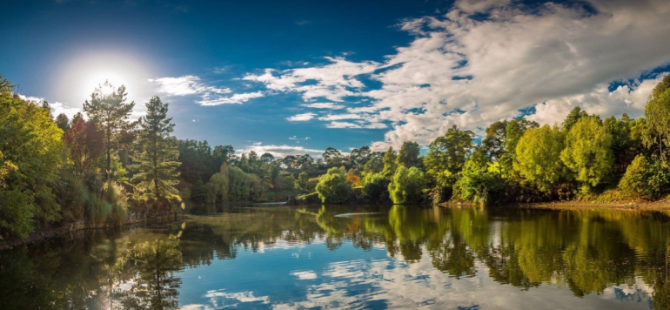
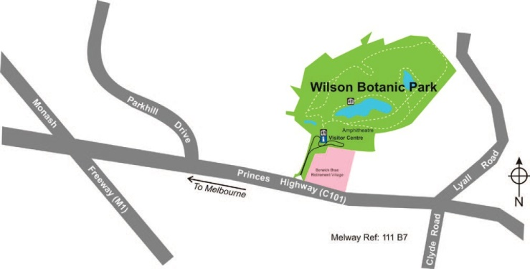

www.facebook.com.au/fowbpb
The Friends of Wilson Botanic Park Berwick are proudly supported
by City of Casey

Become a
Friend of

Who are the Friends?
The Friends of Wilson Botanic Park Berwick is an active community group formed to further the development of Wilson Botanic Park Berwick.
Our Vision Statement is: - Volunteering to safeguard the Park’s Botanical future.

The Friends have been heavily involved in the development and operation of the Park since 1990, prior to the Park opening to the public in 1992.
The role of the Friends is to:
- Encourage appreciation of the natural environment and its value to the community.
- Assist and encourage development of the Park and make representation for its improvement.
- Conduct lectures, functions & activities associated with the Park (or related interests).
- Encourage preservation, research and study of the history and ecology of the Park.
- Assist with the general promotion of the Park.
- Contribute towards the day to day operations of the Park.

Opportunities for Friends

The Friends of Wilson Botanic Park Berwick offer a range of opportunities for you to become involved:
Working Bees - A regular working bee is held on the third Saturday of the month where a team work together to keep the Park looking beautiful.
Visitor Information - Provide Park information and assistance to visitors.
Tour Guides - Conduct guided tours of the Park for clubs and social groups.
Event Volunteers - Assist with the planning of an event or provide assistance during special events held at the Park.
Organization & Development - Take an active role on the Friends executive committee or one of the sub- committees.

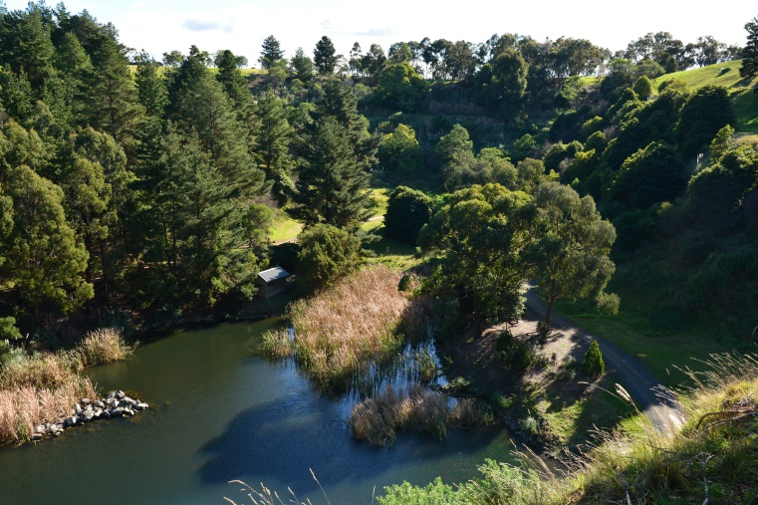

Benefits of Membership
Friends of Wilson Botanic Park Berwick not only meet new people, including many with a keen interest in gardens, they also enjoy many benefits from their membership, including:

  - Guest Speakers
  - Social Activities
  - Special ‘Friends only’ Events
  - Botanical Advice & Information
  - Monthly Working Bee in the Park
  - Quarterly Newsletter

Quarterly meetings and newsletters will keep you informed of what’s happening in the Park, and how you may assist with some of the many wonderful projects or activities organized by the Friends. Supplying your email address will assist us in this.

Your involvement in contributing to such a community facility, will add an extra dimension to your enjoyment of the Park. You will find your participation in the Friends activities fulfilling in many ways.
In joining the Friends of Wilson Botanic Park, Berwick I/We are interested in (please tick)

Working Bees
Reception & Visitor Information Guiding Tours
Special Events
Financial Support Only (No active participation)

How did you find out about us?
----------------------------------------------------------------------------------------------------

Application for Membership
New members are always welcome, simply complete and detach the application form on the reverse side of this page and forward it, together with payment for your subscription to:

Membership Secretary
Wilson Botanic Park Berwick
PO Box 412
Berwick VIC 3806 Enquiries: (03) 9705 5599

All new members need to pay a one-off joining fee of
$5.00 per person on application to receive your name badge.

The membership period is from 1 October to 30 September.

Membership Type:
30/11/2019

Individual | $20
Family | $30
Senior Single | $15
Senior Couple | $20
Junior / Student | $5

