Please submit your form electronically via email: leisure@casey.vic.gov.au
The following fees are charges are applicable for all casual hire at Casey Fields Regional Athletics Centre. All charges include GST.
Application Form
Community Room
Casey Fields Athletics Centre
- Multi-Purpose Community Room Hire
Organisation type | Per hour | Half day  (3 hrs) | Full day  (6 hrs) | Evening
Not for Profit | $50.00 | $123.00 | $208.00 | $323.00
Commercial | $75.00 | $203.00 | $365.00 | $480.00
Refundable bond | $473.00 | $473.00 | $473.00 | $473.00
Contact Information
Organisation:
Postal address: |  | Postcode:
Contact name:
Position:
Phone: (BH) |  | Mobile:
Email:
Booking Requirements
Area | Date of Hire | Time of Hire | Equipment
Community Room |  |  | Yes or No
 |  |  | Yes or No
 |  |  | Yes or No
 |  |  | Yes or No
Purpose of booking:
Please note that your booking is not confirmed until you receive written confirmation from the Sport and Community Connections Team.
Insurance
It is a requirement of Council that all organisations are Incorporated and have Public Liability Insurance. Please provide the following details for your Public Liability Insurance and enclose a copy with this application.
Insurance company: |  | Expiry date:
Policy number: |  | Amount:
Agreement
As a delegate of the organisation listed above, I acknowledge that I have read and agree to abide by the Conditions of use for school hire and undertake to comply with all respects of such conditions should this application be successful.
Name:
Position:
Signed: |  | Date:
It is your responsibility to ensure all other relevant permits or permission including Planning, Health and Local Laws are obtained if required prior to the commencement of any use.
Conditions of use for casual hire
- The Hirer agrees to indemnify and to keep indemnified, the Council, its servants and agents, and each of them from and against all actions, costs, claims, charges, expenses, penalties, demands and damages whatsoever which may be brought or made or claimed against them , or any of them, in connection with the Hirers performance or purported performance of its obligations under this Agreement/Permit and be directly related to the negligent acts, errors or omission of the Hirer/User/Permit Holder.
- The Hirers liability to indemnify the Council shall be reduced proportionally to the extent that any act or omission of the Council, its servants or agents, contributed to the loss or liability.
- The Hirer shall at all times during the agreed Term, be the holder of a current Public liability Policy of insurance (“The Public Liability Policy”) in respect of the activities specified herein in the name of the hirer providing coverage for a minimum sum of $20M (or more).
- The Public Liability Policy shall cover such risks and be subject only to such conditions and exclusions as are approved by the Council and shall extend to cover the Council in respect to claims for personal injury or property damage arising out of the negligence of the Hirer
- Council may cancel bookings at short notice due to inclement weather conditions, ground conditions or other matters that may compromise safety or increase risk of damage to the reserve.
- The hirer must accept responsibility that the reserve is suitable for the desired activities. Council accepts no responsibility for the condition of the reserve or the associated amenities.
- The hiring organisation is responsible for cleaning the reserve. The reserve is to be left in a neat and tidy condition at the completion of use and all rubbish is to be removed from the reserve at the cost of the hiring organisation.
- If Council is required to remove any rubbish left behind as a result of hire, the hirer will be charged accordingly, and an invoice issued for payment. Payment will be required before additional use of Council facilities is allowed.
- Access to the pavilion is to be made by arrangement with Council. A refundable bond may be payable to Council to insure against any damage, cleaning etc, required as a result of the usage. Where a bond is payable a pre and post use inspection of the pavilion should be arranged with the Council.
- The hirer agrees to pay for any required service to return the reserve and/or sports ground and/or pavilion to its pre-use standard.
- Vehicles are not permitted on the reserve without prior approval by Council.
- No nuisance or annoyance shall be caused to persons on neighbouring properties by any activities associated with your function.
- Amusement activities, i.e. inflatable castles etc. and children’s rides are not permitted on the reserve without prior approval by Council.
- Tents, marquees and the like are not to be erected on the reserve due to possible damage to the water reticulation and other underground services; except with prior approval by Council.
- Council prohibits any persons from consuming or bringing any intoxicating liquor on to a reserve without written approval from Council and the necessary permit from the Victorian Commission for Gambling and Liquor Regulation.
- This form is to be taken to the ground and presented as proof of booking when requested by Council Officers.
- Facilities in the reserve are for public use and must be shared
Privacy Statement
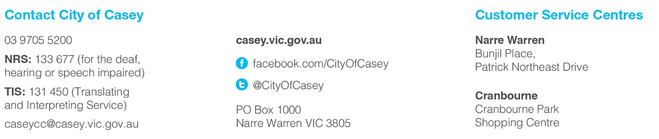
City of Casey is committed to protecting your privacy. Your personal information will be handled in accordance with the Privacy and Data Protection Act 2014. All personal information collected by the City of Casey will only be used for the purposes outlined within our Privacy Policy. Council’s Privacy Policy is available from our website www.casey.vic.gov.au/council/your-council/privacy and all Council Customer Service Centres. For further Information about how Council manages and uses your personal information or how you can access and/or amend your personal information please contact Council’s Privacy Officers via our website www.casey.vic.gov.au/council/contact/feedback-form or by calling on 9705 5200.

